Title of your abstract (Times New Roman 14pt, bold)

Author 1 ª, Author 2 ^{b}, Author 3 ^{c}, Author 4 ª, Author 5 ^{c}, … (Times New Roman 11pt )
(underlined author = presenting author)
ª Institute 1, City, Postal code, Country (Times New Roman 11pt)
^{b} Institute 2, City, Postal code, Country
^{c} Institute 3, City, Postal code, Country
e-mail: xxx@xxx.xx.xx
(e-mail of corresponding author; not necessarily the first author or the presenting author)

Abstract Text (Times New Roman 11pt, single spacing)
Each abstract must state clearly:
• Purpose of the work;
• Novelty of the work with respect to the state of the art;
• Results of the work.

Authors are asked to submit a two-page abstract. The first page should contain text only, while the second page should contain figures, tables and captions. Use single line spacing and justified alignment with 11-point Times New Roman font for the main text and 14-point Times New Roman Bold for the Title. Pages should not be numbered. An additional short abstract of maximum 100 words will be also required in the online submission procedure.

If you use MSWord, please use this template to start writing your manuscript, but make sure that in the page setup the paper size is set to A4 (top and bottom margins are 22.5 mm; left and right margins are 20 mm). If you are using Latex or another word-processing program, make sure your manuscript margins and column settings follow the prescribed rules. Specify page size as A4.

Figure captions and References should be 11 pt Times New Roman with single spacing.
Figures: Photographs and pictures must be of impeccable grayscale quality. Figures should be referenced in the text (see Figs 1 and 2). Handwritten lettering on figures is not acceptable. Figures should have a short caption, placed directly underneath them and centred, with a concise explanation of the content.

References: The reference list should be written as in the examples given hereafter for articles in journals [1], books [2], papers in a contributed volume [3], and thesis or unpublished work [4].

IMPORTANT DETAILS FOR ABSTRACT PREPARATION:
- Only PDF-Format is accepted. Please convert your final Word file to Pdf.
- Please resize your figures before importing them to Word, to conform to maximum size of 5 MB pdf file. Resizing is attainable in all common image software (e.g. MS Paint uses Image - Stretch, Adobe PhotoShop uses Image Size as shown in Fig 3).
- Abstracts should be submitted on-line via https://mne2024.imnes.org. Abstracts submitted via fax or e-mail will not be accepted.
- If you need additional information, please contact the conference secretariat: contact@mne2024.imnes.org.

[1] A. Qualtieri et al., Microelectron. Eng. 84 (2010) 1435-1438.
[2] E. Borger, Computability, Complexity, Logic (North-Holland, Amsterdam, 1989).
[3] A.K. Lenstra and H.W. Lenstra, Jr., Algorithms in number theory, in: J. van Leeuwen, ed., Handbook of Computer Science, Vol. A (Elsevier, Amsterdam, 1990) 673-715.
[4] A. Rajasekar, Semantics for logic programs, Ph.D. Thesis, Department of Computer Science, University of Maryland, 1989.
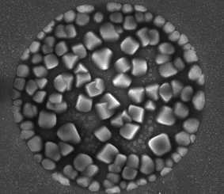

Figure 1. Insert a concise explanation of figure 1 here. Figure may be color or grayscale and should include a scale bar where relevant.

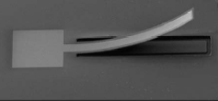

Figure 2. Photographs and pictures must be of good quality color or grayscale.

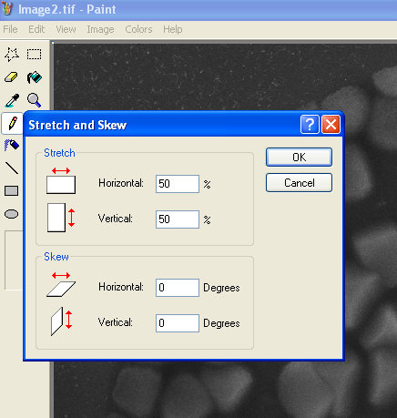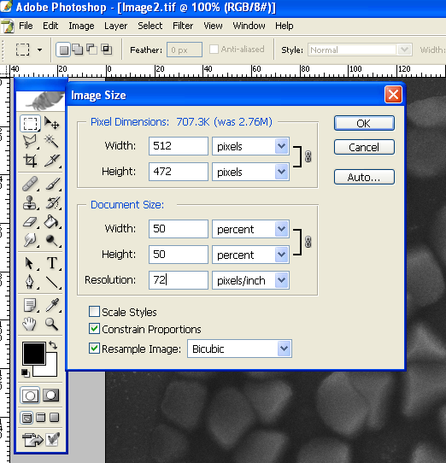

Figure 3. Stretch to 50% in MS Paint reduces the size of your image by a factor 4 (e.g. 1MB becomes 250KB upon saving your image). Resize to 50% of original in Adobe PhotoShop reduces the size of your image by a factor 4 (e.g. 1MB becomes 250KB upon saving your image). Use these reduced images to import in Word.

